**JUNK FILE ORGANIZER**

**A mini python project in which I tried to create a file organizer that can organize files based to date, year, type, size and extension**

**Table of contents**

* Junk File Organizer
  + Table of Contents
  + Technologies
  + Setup
  + Syntax
  + Executable File
  + Usage
  + Output

**Technologies**

Project is created with

* + Python: 3.8.5
  + Flake8(for linting)

**Setup**

To run this project:

1. Clone this repo
2. Install Python 3
3. Install Flake8 library
   1. Pip install flake8
   2. Run python -m flake8 command and check for any errors
4. Run python3 main.py -h
   1. There you can see all the details of the project
   2. -p/--path is the flag for specifying the path
   3. -o/--order is the flag for specifying the order
   4. -h/--help is the flag to get help
   5. Path is mandatory to specify
   6. Order is optional, by default the sorting order will be of type
5. After running the program you will get a successful message
6. Go to the path and look the folder the organized or not

**Syntax**

Note:- please make sure you follow the commands properly

Command Syntax : python3 main.py -o <order> -p <path>

<order> - order can be size, type, extension, date or year

<path> - absolute path of the folder to be organized

**Usage**

* **For Organizing by extension**

python3 main.py -p /Users/mintukrishnan/Downloads -o extension

* **For organizing by size**

python3 main.py -p /Users/mintukrishnan/Downloads -o size

* **For organizing by date**

python3 main.py -p /Users/mintukrishnan/Downloads -o date

* **For organizing by year**

python3 main.py -p /Users/mintukrishnan/Downloads -o year

* **For organizing by type**

python3 main.py -p /Users/mintukrishnan/Downloads -o type

note: /Users/mintukrishnan/Downloads - This is my path where my junk files reside. You need to get your file path

**Executable File**

Go to github repository open 'mac application/main-prompt.app/Contents/MacOS/main-prompt' and run it.

**Output**

**When you run help flag :** python3 main.py -h

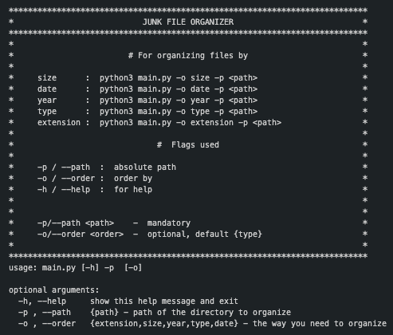

**Files before organizing**

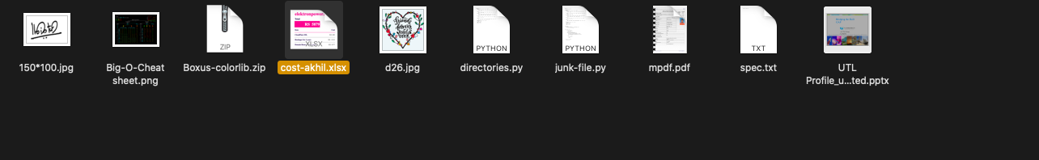

**When organized by extension**

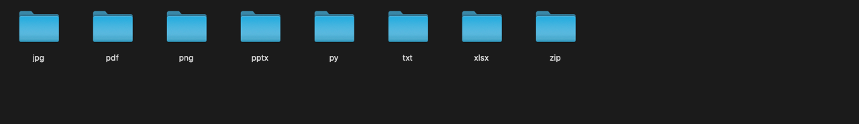

**When organized by size**

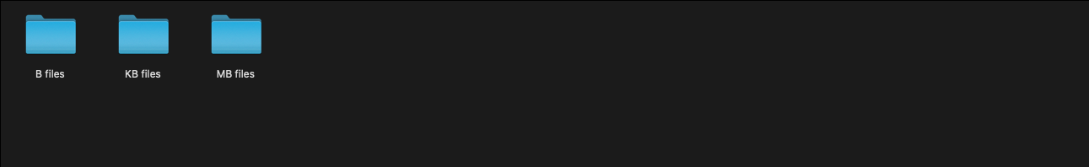

**When organized by date**

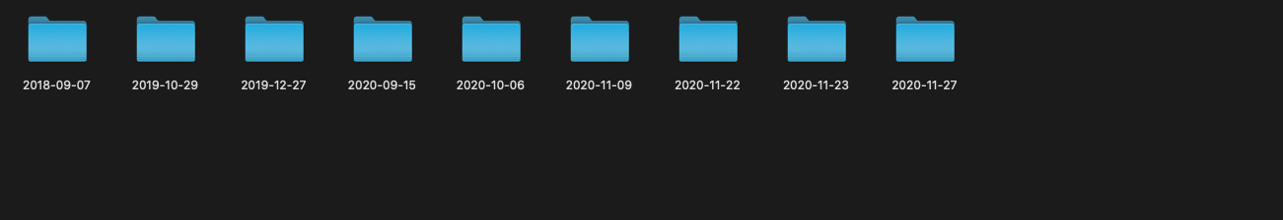

**When organized by year**

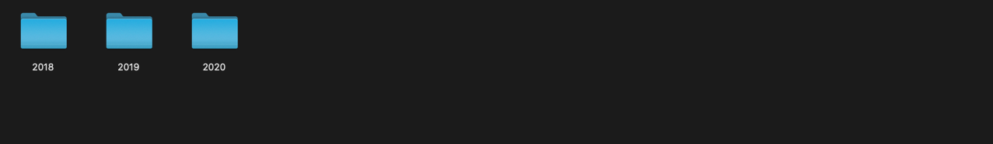

**When organized by type**

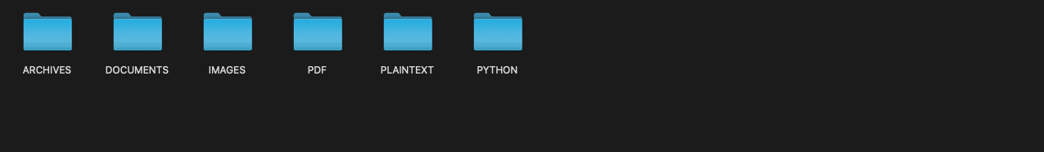

**Mac and Linux executable app**

If its not opening in your linux or mac system.

Then right click on the main-prompt.app --> show package contents --> contents-->MacOS --> run main-prompt

